## Basics

### Open Source

firefox

VLC

Blender

GIMP

Audacity

Wordpress

### Architecture

### File Architecture

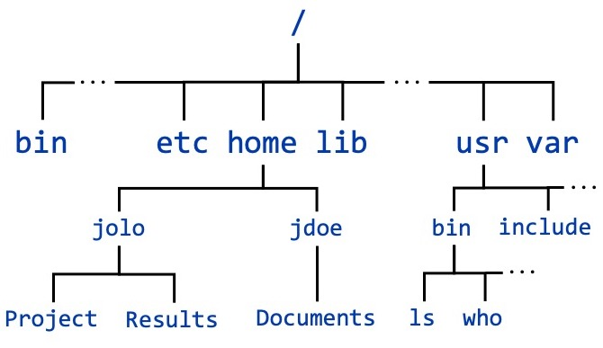

## 

## Command Line Interpreter

Shell

ksh

tcsh

zsh

Fish

bash

### structure

command

command + options

command + arguments

### Basic commands

ls

-l

-a

-i inode

pwd

clear

cd

dir_name

.. parent

~ home directory

whatis

man

1 commands

2 system calls

3 functions

7 signals

## Files & Directories

absolute

relative

### basic commands

mkdir

cd

cp source dest

mv (move)

(rename)

rmdir delete empty directory

rm delete a file

rm -r delete directory recursively

#### viewing

cat

head

tail

less

nl

### editors

nano

vi (vim)

gedit

atom

sublimetext

vscode

emacs

notepad++

### redirection

>

>>

## vi (vim)

### modes

#### insertion

i

#### command

esc

:w save

:wq save & quit

:q! quit without saving

:w! save as

yy copy a line

4yy copy 4 lines

yiw copy a word

p paste after the cursor

P paste before the cursor

dd deleting a line

cut

diw delete 9cut) word under the cursor

3dd delete 3 lines

u undo

ctrl + r redo

/pattern search for the pattern

n move o the next pattern

## Users & groups

### commands

su

### root

super user

* full read/write/execute privileges
* creating or installing software
* modifying files & settings
* creating or deleting users and data

sudo (superuser do)

yearly_training.data

modes of a file:

read write execute

user group others

r w r w r -

marvels.txt

r w - r - - r - -

1 1 0 1 0 0 1 0 0

6 4 4

644 to 646

u user

g group

o others

r read

w write

x execute

-w remove write for all

g+x add execute permissions for group

### commands

chmod

chown

chgrp

useradd create/add a user

passwd

groupadd create a group

usermod modify user settings

rwx rwx r-x

775

## intermediate commands/concepts

### wc

-l

-c

-w

### pipe |

grep

-n

### tar archive

TAR TapeARchive

gzip

tar.gz

.tgz

bzip

.tar.bz2

tar xf file.tar -C directoryname

tar xf file.tar.gz -C directoryname

tar xf file.tar.bz2 -C directoryname

unzip file.zip -d directoryname

### links

2 kinds:

1. hard links
2. symbolic (short) links

## shell expansions

### wild cards

* placeholder for 0 to n number of characters

? single character

{ }